HELLENIC REPUBLIC | FACULTY OF HEALTH SCIENCES
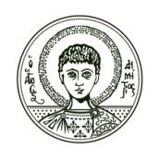 | DEPARTMENT OF MEDICINE  MSc in MEDICAL RESEARCH METHODOLOGY
ARISTOTLE  UNIVERSITY  THESSALONIKI | T: +30 2310 99 9333  F: +30 2310 99 9293  E: info-mrm@auth.gr  W: mrm.med.auth.gr | Thessaloniki, 12 July 2017

Statement of purpose

Applicant name, surname
Relevant academic, research or practical experience
Reasons for applying to this particular programme
Areas of study in the subject that interest me

