HELLENIC REPUBLIC | FACULTY OF HEALTH SCIENCES
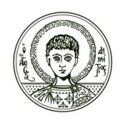 | DEPARTMENT OF MEDICINE  MSc in MEDICAL RESEARCH METHODOLOGY
ARISTOTLE  UNIVERSITY  THESSALONIKI | T: +30 2310 99 9333  F: +30 2310 99 9293  El: info-mrm@auth.gr  W: mrm.med.auth.gr | Thessaloniki, 10 September 2018

Application form

Please, accept my application form for the MSc Program in Medical Research Methodology

Name

Surname

Father’s name

Mother’s name

Nationality

Address

Zip code

City

Phone

E-mail

I hold a bachelor/MSc/PhD/other degree(s) in/from:

Thessaloniki, / /2018

Attachments

- Bachelor/MSc/PhD/Other degree(s).

- Recognition Degree from D.O.A.T.A.P. (if needed)

- Recently updated Curriculum Vitae, with details about education, training, work experience, academic publications and academic achievements (i.e. Europass template).

- Proof of competency in English language.

- Photocopy of personal ID or passport with personal details.

- Two (2) reference letters.

